Hakan Turgut

CS 370 Project

**Under Armour Vision User Manual**

1. How to compile and run Under Armour Vision System:

Open Command Line

* + 1. To set the path to the flash drive: cd /volumes/UAVD
    2. To Compile, type: javac User.java
    3. To Run, type: java User backUpData.txt

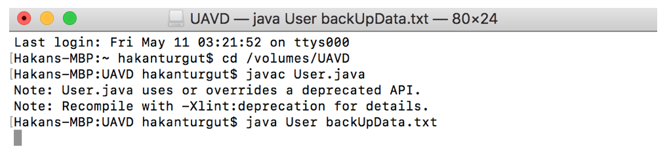

Note: The name of the flash drive is UAVD

1. After following step 1, a login window will appear. This will allow us to either log in as a user or administrators. Users have the ability to search for Under Armour items and use the offline query option to view information about existing items in the hash table. Administrators can search for items, obtain information about existing items in the offline query option, add, modify, and delete items, view the transaction log, and view all of the data stored in the hash table and backup.

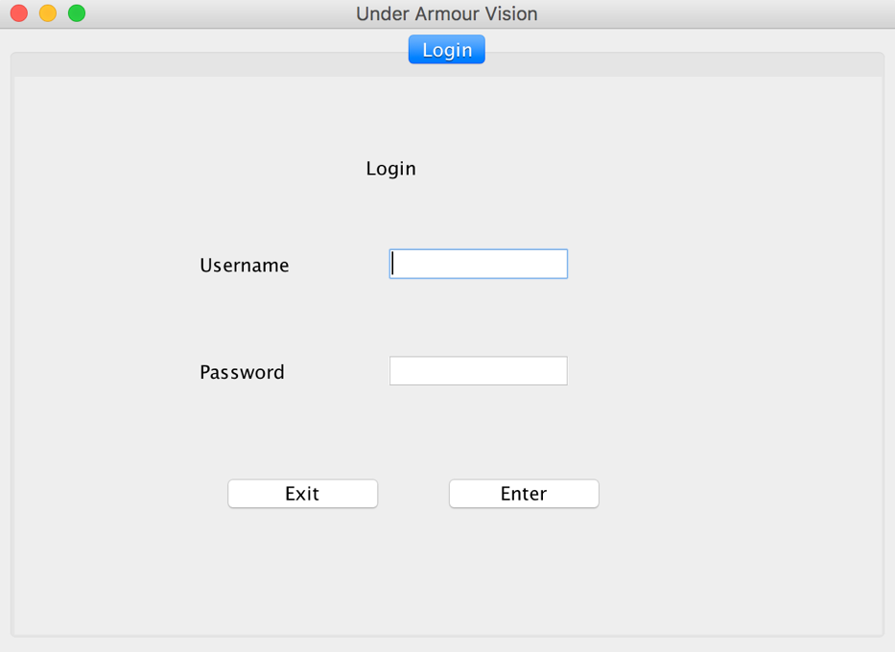

The username field and the password field must both filled be in. The login button must then be pressed.

* 1. To log in as an administrator:
     1. Username: administrator
     2. Password: 1111
  2. To log in as a user:
     1. Username: user
     2. Password: 0000

In this example, we will log in as an administrator. We type in "administrator" in the username field and "1111" in the password field. We then press the Enter button.

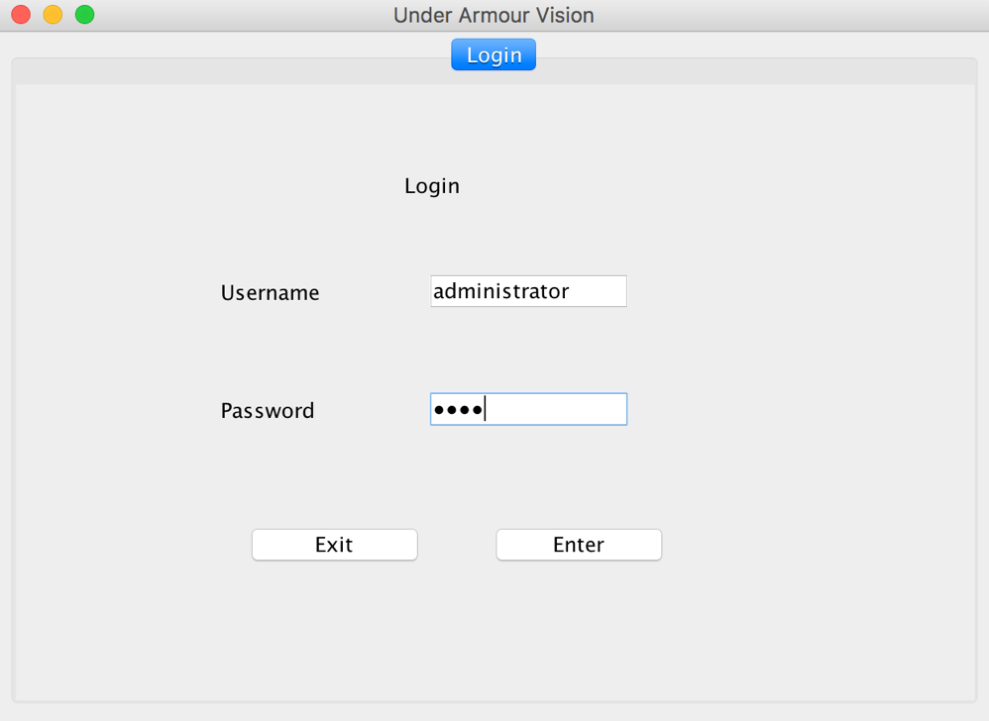

1. After successfully logging in as an administrator, five more tabs will be displayed. They consist of Search, Offline, Add/Edit, Delete, System, and Login.

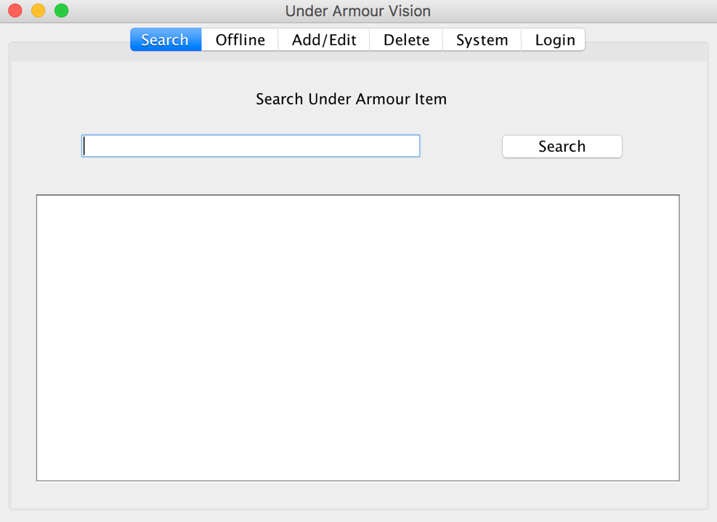

1. In the Search tab, various Under Armour items can be searched for. This will require an internet connection. The search result will display a list of all of the items associated with the search made. This will show the number, name, wear, price, and color availability of each item in the search result. All of the items in the search result will also be stored in to the hash table by the system. If users/administrators want to view or download the image of a particular item they found in the search results, they will have to go to the offline tab (after searching the item in the Search tab so that it can first be stored in the hash table) and then type in the item number for that item.

The user/administrator must type a search word(s) and click on the Search button. In this example, "shirts" is entered. The search result is a long list of all the Under Armour shirts. Note: Depending on your internet connection, there may be a 5 second delay.

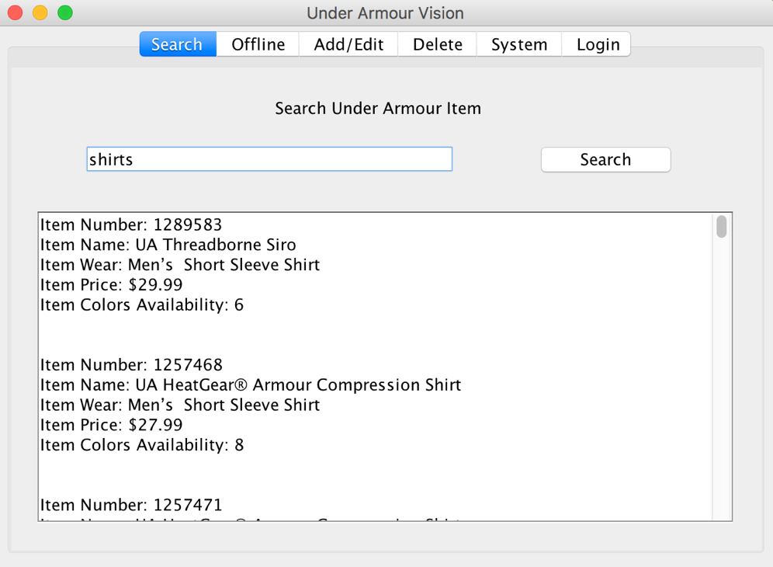

Any search, related to under Armour items will display results. Searches can consist of "shirts," "shoes," "pants," "shorts," "red," "blue", "soccer," "basketball," etc.

1. In the Offline tab, you can obtain information about existing items in the hash table whether they were stored from searches or manually added by administrators. As a result of this, an internet connection isn't required as it was in the Search tab.

When making an offline query to obtain more information about a particular item, the item number must be entered. The user/administrator must then press the Enter button. This will pull up the image of the item, name, type of wear, price, and number of colors offered. In addition to this, the Download Image button can be pressed, which will save the image to the computer (The downloaded image will be saved to the project folder).

Note: Not all items in the under Armour website have images. The items that do have images will be listed at the top of the search results in the Search tab while the ones that don't have one will be listed towards the bottom.

In this example, we entered item number "3000094," an item that was immediately stored in to the hash table after another search, "shoes" was made in the Search tab. Even if we had suddenly lost internet connection, we would still be able to access this information since the item exists in the hash table. After pressing the Enter button, we can see all of the information about this item including its image. We then press the Download Image button to save the image in to the project folder (This prints a message to the output console that the image was successfully downloaded).

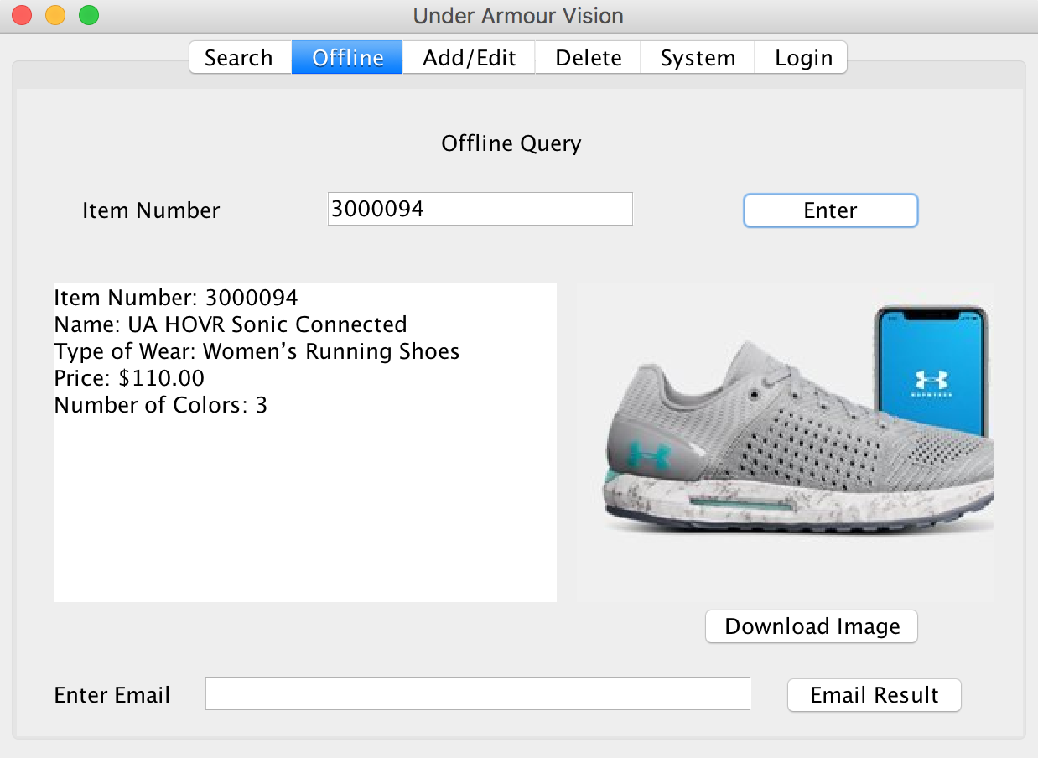

1. In the Add/Edit Tab, administrators can insert new items in to the hash table and modify ones that already exist

The add feature allows administrators to insert new items and their information in to the hash table.

This will require the administrator to enter the number, name, wear, price, and color availability. After this, the Add Item button must be pressed. (Note: In order to add new items, the item number cannot be the same as an existing item. Additionally, none of the fields can be left blank.)

In this example, we enter "3333333" in to the Item Number field, "UA Summer Shorts" in to the Item Name field, "Men's Shorts" in to the Item Wear field, "34.99" in to the Item Price field, and "5" in to the Color Availability field. Finally, we press the Add Item button.

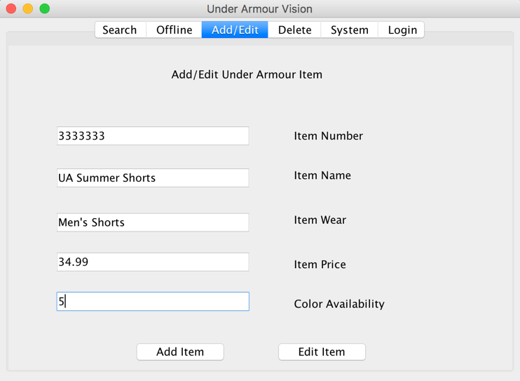

The edit feature allows administrators to modify existing items in the hash table. The name, wear, price, and color availability can be changed of any item.

In order to edit an item, the item's number must be specified in its field. Any of the following fields below it can be filled in order to change the name, wear, price, and/or color availability. The Edit Item button must then be pressed.

Referring back to the item number 1228539, an item we know that exits in the hash table (after searching "Shirts" in the search tab), we will edit the wear, price, and color availability. By doing this, we type in "1128539" in to the Item Number field, "Men's long Sleeve Shirt" in to the Item Wear field, "41.99" in to the Item Price field, and "10" in to the Color Availability field. We then press the Edit Item button.

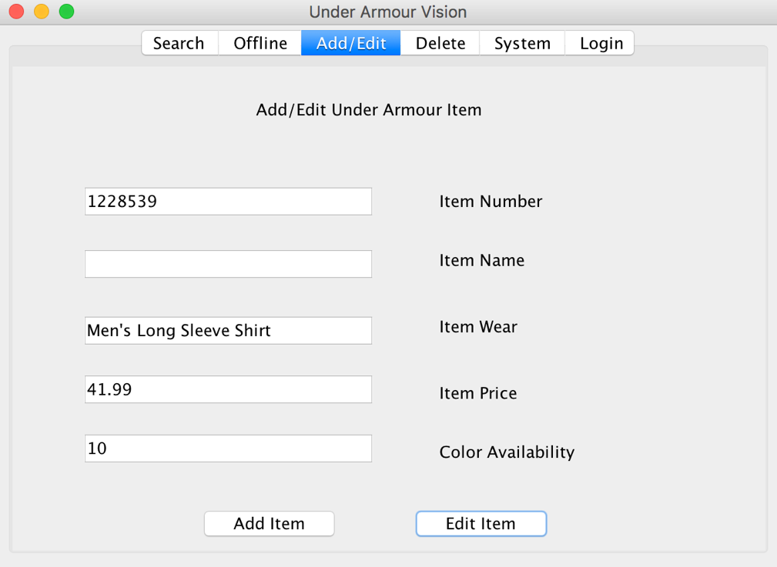

1. In the Delete tab, items that already exist in the hash table can be deleted.

The requirement for deleting an item is entering its item number. To complete this transaction, administrators must press then press the Delete button.

In the example below, we will delete the item with the number 1300002 (An item that was stored after searching "Shirts." By doing this we enter "1300002" in to the Item Number Field and then press the Delete Button.

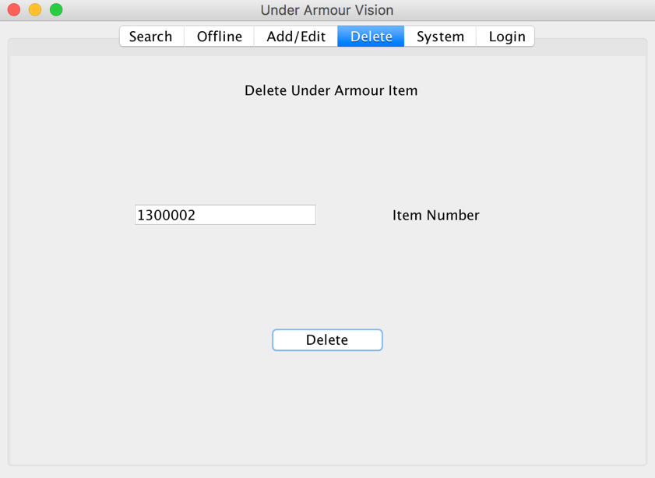

1. Under the system tab, administrators have different options of viewing data.

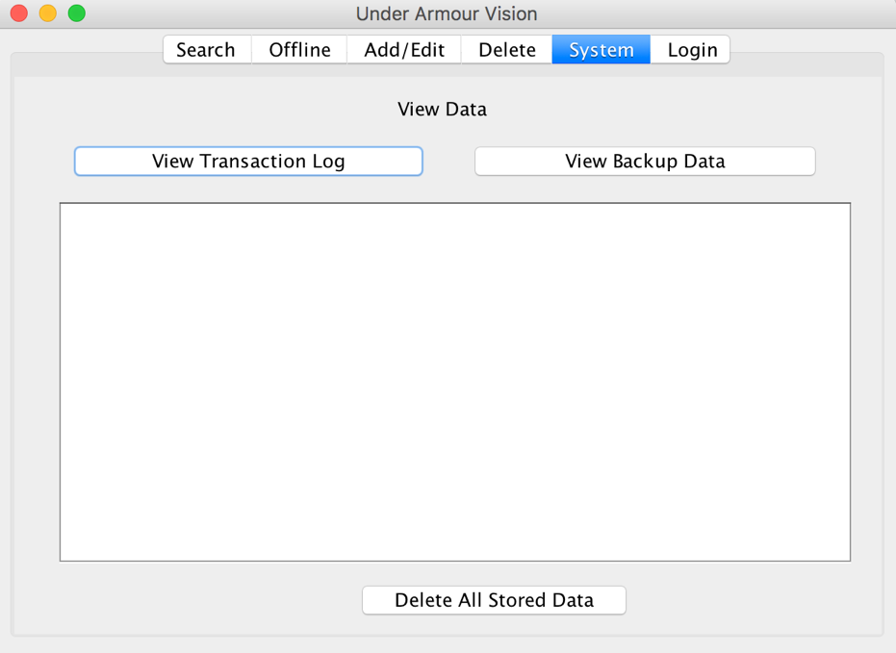

By clicking the View Transaction Log button, all activity that involves modifying data in the hash table will be displayed. For each activity, the transaction log records the time, the description of the activity, the item number of the item that was added, modified, or deleted, and its other attributes. The transaction log in this GUI records all of the activity for the current execution of the system. If administrators want to view a transaction log of every single activity, including those that happened in previous system executions, then they can access the transaction log text file (transactionLog.txt) which is available in the project folder

Start of list:

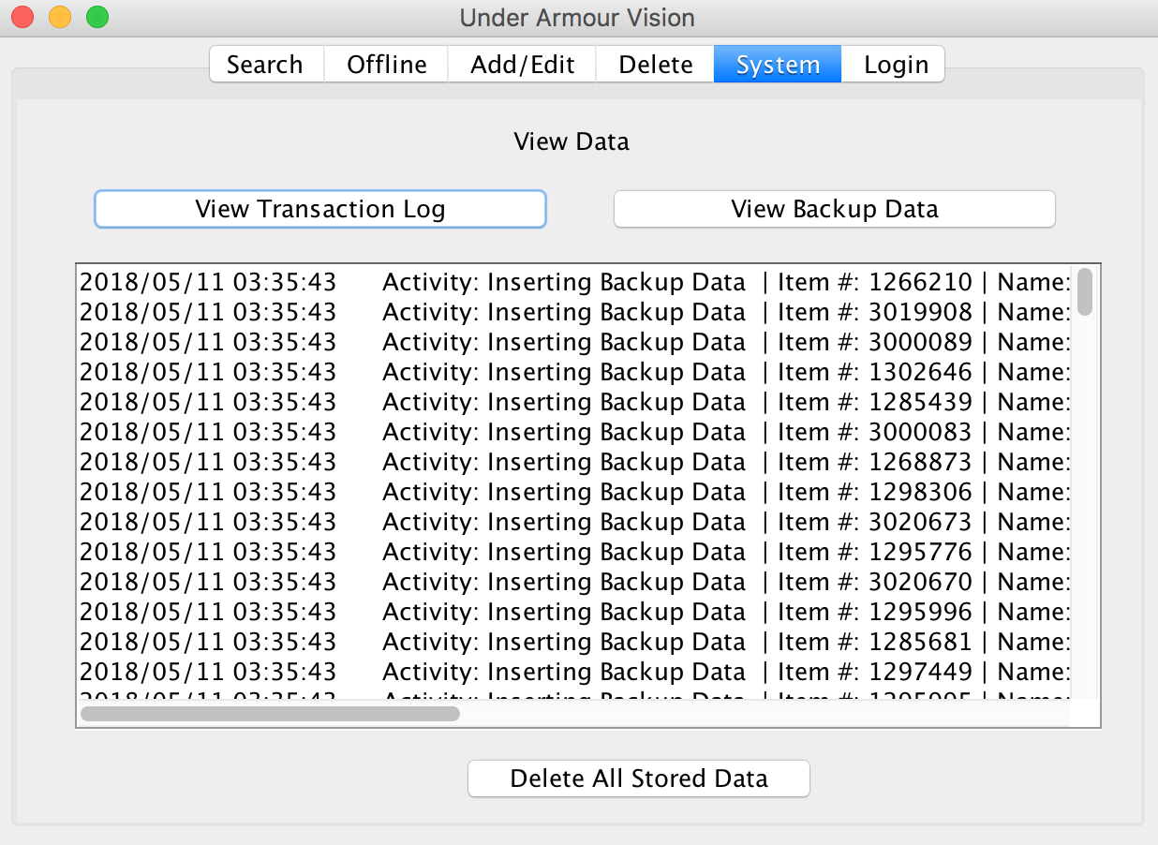

End of list:

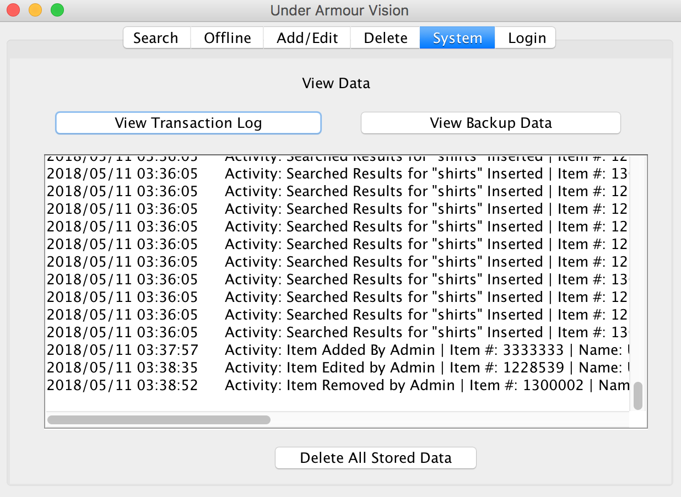

Right Side View:

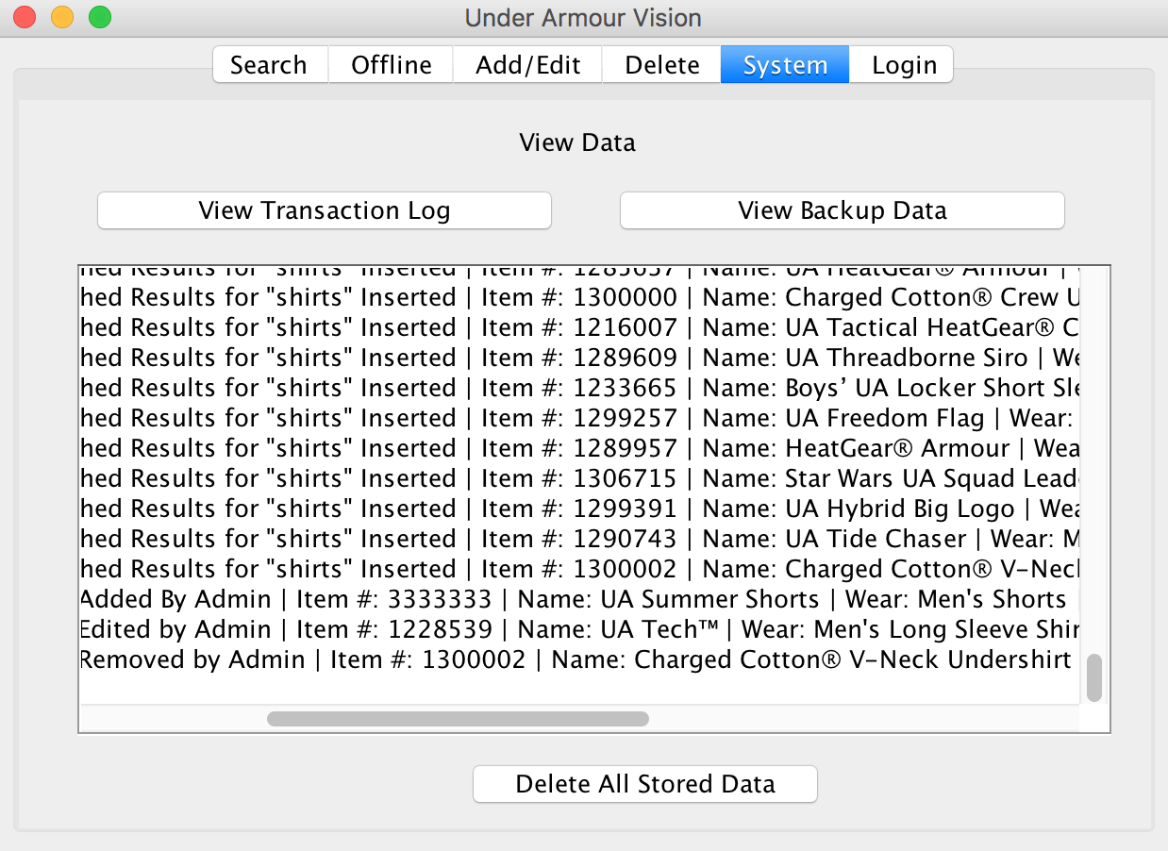

Transaction log in text file (transactionLog.txt):

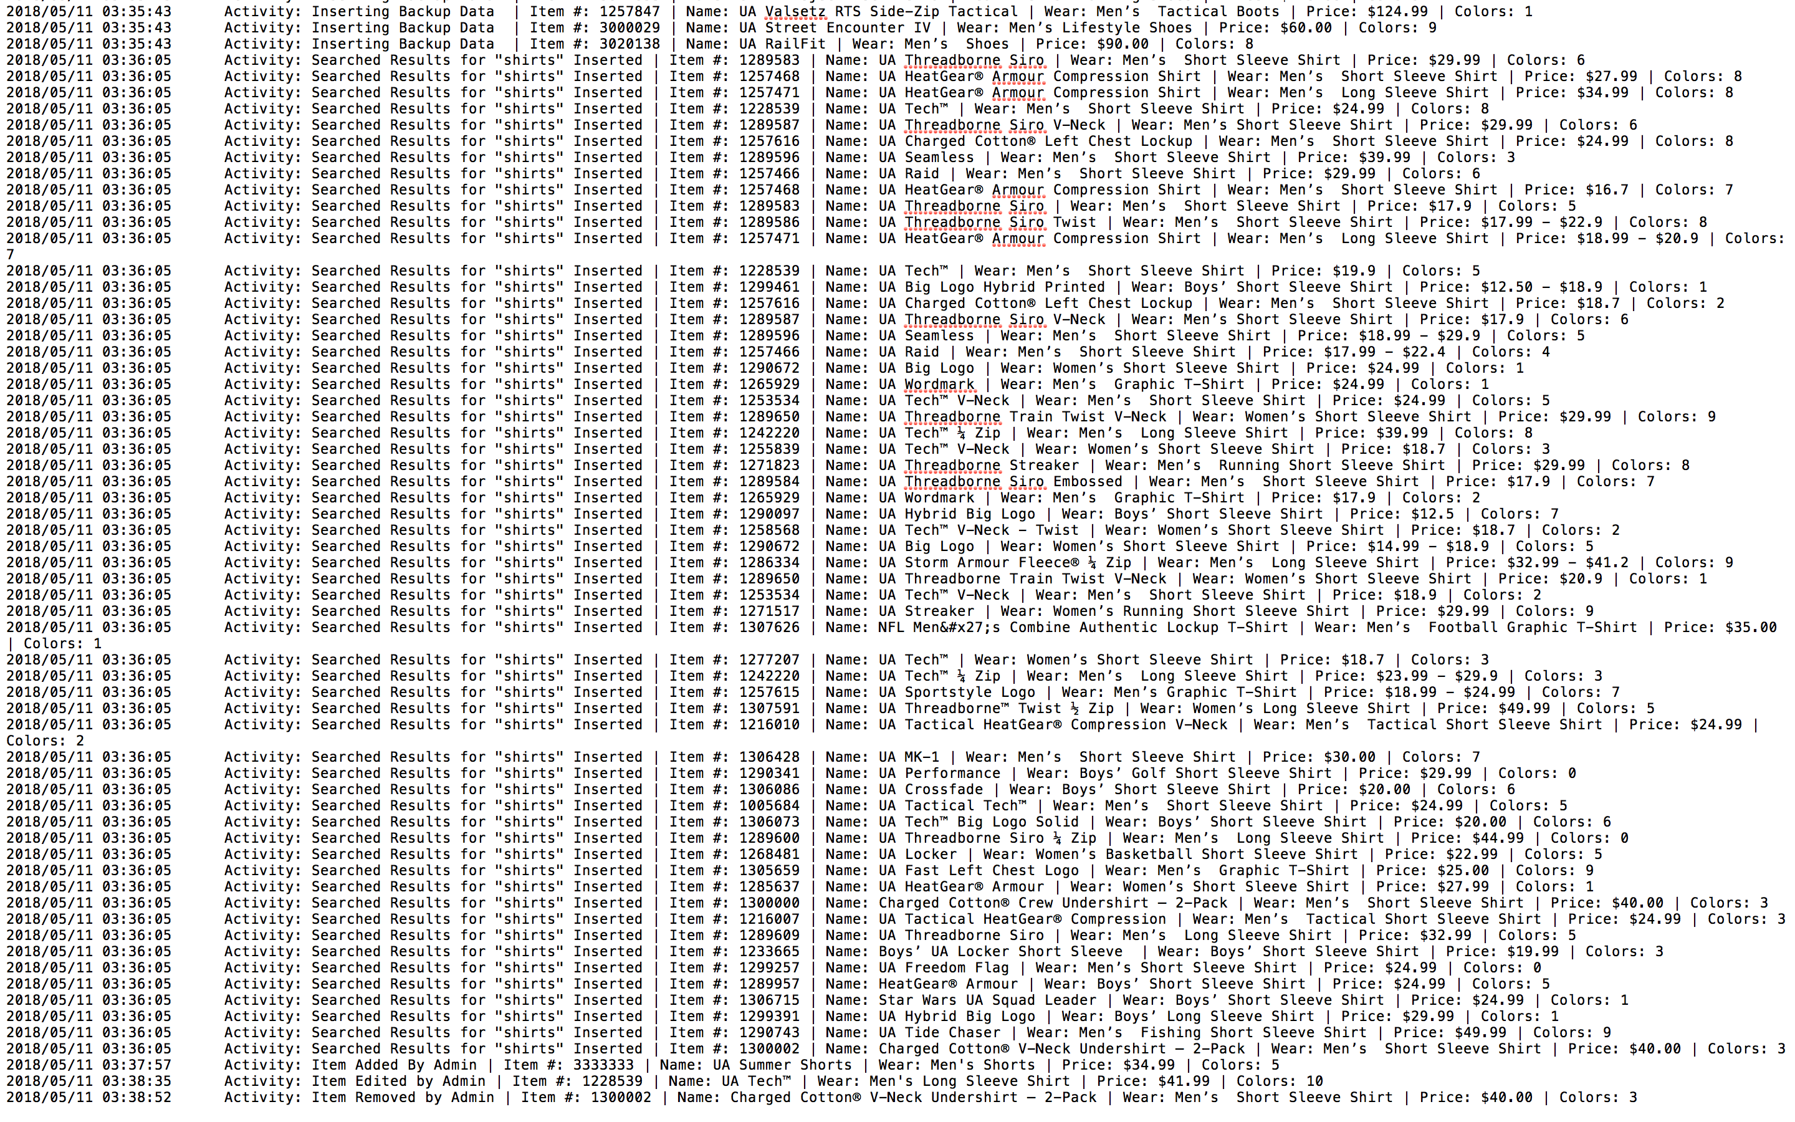

By clicking the "View Backup Data" button, administrators can view every single item (and its attributes) that is currently stored in the hash table.

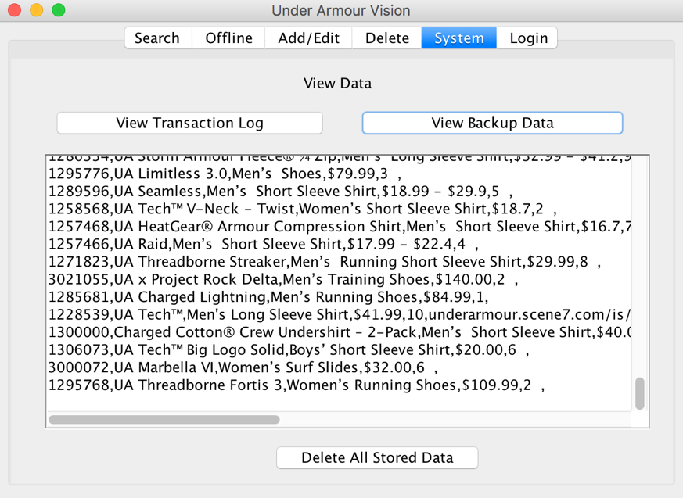

Additionally, there's a button called "Delete All Stored Data". By pressing this, all of the data in the hash table and backup data in the backUpData.txt file will be deleted.

1. The login tab allows users and administrators to easily log in and out without terminating the system. If administrators are currently logged in under the administrator account, they can go to the Login tab and enter the username and password for a regular user. After pressing the Enter button, they will now be logged in as a user. As a user, you are limited in what you can do in the system. The Add/Edit, Delete, and System tabs are now gone since users are not allowed to directly modify data in the hash table. They can however, make online searches (which will store new data in to the hash table) to find various Under Armour items. They can also use the offline tab to view the information about items that already exist in the hash table.

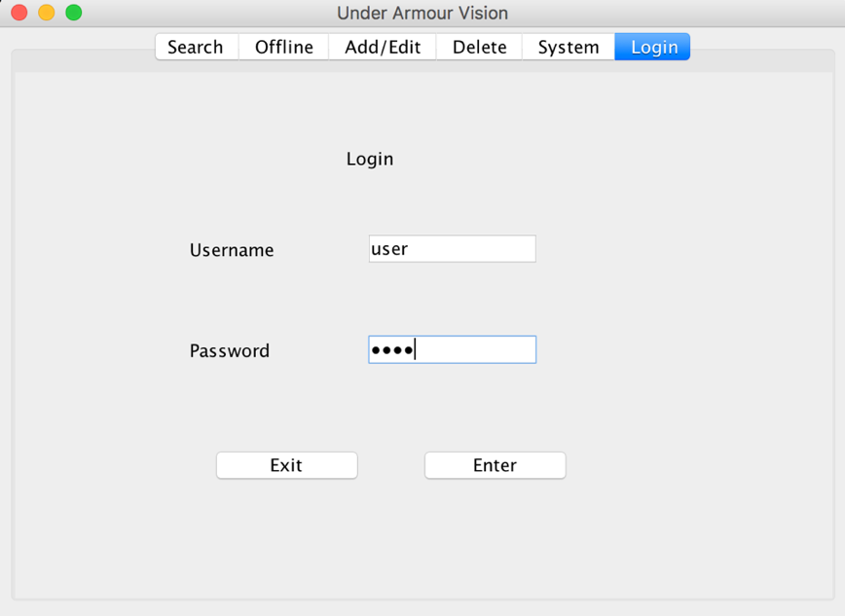

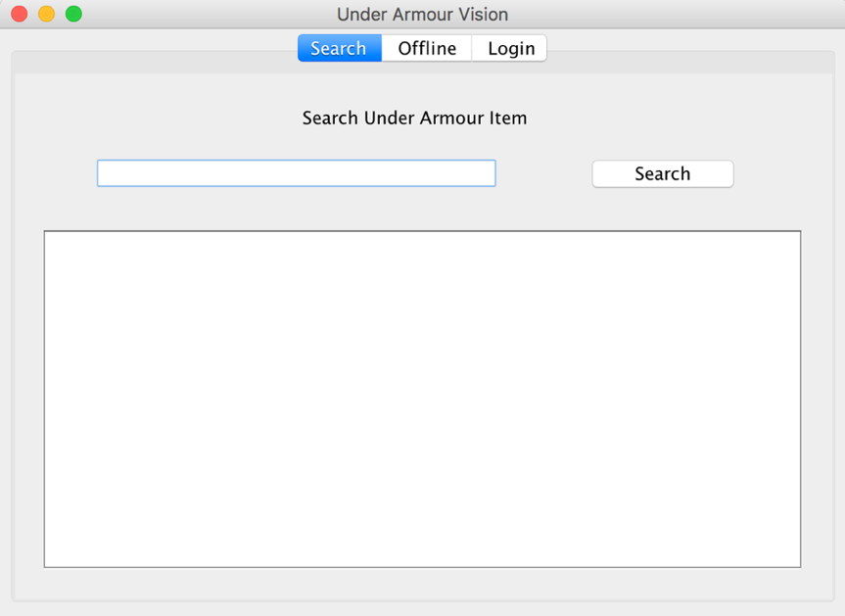

Note: Every time a change is made to the hash table (adding, removing, or modifying the items), the data and those changes will be backed up in to a file. As a result of this, there is always persistence of data. If the system is intentionally or unexpectedly terminated and then executed again, the first action that the system will take is to read the data backed up in the text file from the previous execution of the system and then store it back in to the hash table.